PROJECT REPORT
Scientific Calculator in MASM (Assembly Language) Using Irvine32 Library

Group Members
- Umna Syed – [24K-0909]
- Vaania Ahmad – [24K-0504]
- Abeer Fatima – [24K-0985]

Submission Date
23rd November, 2025.

1. Executive Summary

Overview
This project is a fully functional Scientific Calculator developed in x86 Assembly Language (MASM) using the Irvine32 library.
The calculator supports a wide range of operations including:
- Basic arithmetic
- Power and factorial
- Matrix addition and multiplication
- Permutation and combination
- Percentage
- Square / Cube
- Trigonometric calculations (sin, cos, tan)
- Negative exponent fractional form
The entire system runs in the console, displays a user-friendly menu, and executes each operation through dedicated procedures.

Key Findings
- Assembly language can efficiently implement complex mathematical functions.
- Modular design using procedures increases readability even in low-level languages.
- Advanced features like matrix multiplication and trigonometry can be achieved with FPU instructions and loops.
- Error handling (e.g., division by zero, invalid matrix sizes) ensures program reliability.

2. Introduction

Background
Object-Oriented Programming concepts such as modularity, abstraction, and reusability inspired the structure of this Assembly-language project. Although MASM is not OOP, the procedure-based modular structure mimics OOP ideas:
- Each operation is its own module (procedure).
- Data is organized in separate blocks.
- The main menu acts as a controller directing flow—similar to OOP method calls.

Project Objectives
- Develop a complete Scientific Calculator using Assembly language.
- Implement modular procedures to simulate object-oriented structure.
- Integrate advanced mathematical operations like trigonometry and matrix operations.
- Provide user-friendly menu-driven interaction.
- Apply programming fundamentals (loops, conditionals, arithmetic, FPU instructions).

3. Project Description

Scope
The project covers:
- Basic arithmetic (Add, Subtract, Multiply, Divide)
- Factorial, Power (positive & negative), Percentage
- Square, Cube
- nPr and nCr
- Matrix Addition & Matrix Multiplication
- Trigonometric Functions (sin, cos, tan in degrees)
- Error messages for invalid inputs

Technical Overview
Tools & Technologies:
- MASM (Microsoft Macro Assembler)
- Irvine32 Library
- Visual Studio / MASM611 / VSCode with MASM extension
- x86 architecture
- Math FPU instructions (FSIN, FCOS, FPTAN, FSTP)

4. Methodology

Approach
- Weekly development with incremental testing.
- Start with basic arithmetic and build up to advanced operations.
- Use modular coding (procedures) for maintainability.
- Testing each procedure standalone before integration into main menu.

Roles and Responsibilities
- Abeer Fatima — Core Arithmetic & Advanced Operations (5 Functions)
Functions Assigned:
- Matrix Addition
- Multiplication
- Power
- Division
- nPr (Permutation)

Responsibilities:

1. Implement Basic Arithmetic Operations
- Designed and coded integer multiplication using signed imul instruction.
- Implemented division with proper handling of quotient and remainder using idiv.
- Added validation for division by zero and displayed user-friendly error messages.

2. Power Function Implementation
- Developed a complete power calculation module supporting:
  - Positive exponents
  - Zero exponent
  - Negative exponents (fractional form output)
- Implemented special behavior for base values 1 and -1.

3. Permutation (nPr) Calculation
- Wrote logic for computing nPr using factorial function calls.
- Handled invalid input cases (e.g., r > n) with appropriate error messages.

4. Matrix Addition Function
- Designed input collection for 2D matrix values.
- Implemented dynamic row × column processing (up to 3×3).
- Added nested loops to perform element-wise matrix addition.
- Ensured correct formatted output of resultant matrix.

5. Integration into Main Menu
- Ensured all Person 1 functions were menu-driven.
- Connected label jumps and call instructions properly.

- Umna Syed — Secondary Arithmetic & Matrix Multiplication (4 Functions)
Functions Assigned:
- Matrix Multiplication
- Addition
- Subtraction
- Square

Responsibilities:

1. Develop Matrix Multiplication Algorithm
- Implemented complete matrix multiplication using 3 nested loops (i, j, k).
- Zeroed matrix C before performing multiplication.
- Validated multiplication conditions (columns A == rows B).
- Printed results in a structured matrix form.

2. Implement Basic Arithmetic Operations
- Created optimized routines for addition and subtraction using registers.
- Ensured clean user input handling for both operands.
- Displayed results with proper formatting.

3. Square Function
- Implemented logic for squaring a number using imul.
- Integrated this function cleanly within the menu.

4. Testing & Debugging
- Verified correctness of all arithmetic functions.
- Debugged matrix operations involving pointer offsets and index calculation.

- Vaania Ahmad — Scientific Functions & Utilities (5 Functions)
Functions Assigned:
- Trigonometric Functions (sin, cos, tan)
- nCr (Combination)
- Factorial
- Cube
- Percentage

Responsibilities:

1. Trigonometric Function Module
- Built a sub-menu for sin, cos, and tan operations.
- Converted degree input to radians.
- Used x87 FPU instructions (fsin, fcos, fptan) for computation.
- Implemented a fixed-point float printer for readable output.

2. Combinations (nCr) Function
- Calculated nCr using factorials and division.
- Ensured correct computation of n!, r!, and (n−r)! using Fact procedure.
- Added validation checks (e.g., r ≤ n).

3. Factorial Implementation
- Developed iterative factorial logic using loops.
- Returned results through a shared variable for reuse in nPr and nCr.

4. Cube Function
- Implemented cube(x) = x³ using two mul instructions.
- Used stack parameters for proper calling convention.

5. Percentage Function
- Coded percentage formula: value * percent / 100.
- Displayed result followed by the % symbol.
- Ensured the procedure used stack parameters and returned cleanly.

6. Documentation & Menu Integration
- Added clear prompts for each trigonometric and percentage function.
- Ensured smooth return to the main menu after each operation.

5. Project Implementation

Design and Structure
The project uses a menu-driven structure. Each menu option calls a separate procedure, similar to calling methods in OOP.
Main structure:
- .data → All messages, variables, matrices
- .code → All procedures
  - addProc, subProc, Multiplication, DivisionOperation
  - PowerCalculation, Fact, sqProc, CubeProc
  - MatrixAddition, matrixMulProc
  - PermutationCalculation, CombinationCalculation
  - TrigonometricCalculation, ReadAngleToST0, PrintFixedFloat
  - main menu loop

Functionalities Developed
- Arithmetic operations: Addition, subtraction, multiplication, division with quotient & remainder
- Power calculation (supports negative exponents)
- Factorial using loop
- Square / Cube
- Percentage calculation
- nPr / nCr
- Matrix Addition (up to 3×3)
- Matrix Multiplication (size validated)
- Trigonometric functions using FPU and degree-to-radian conversion
- User-friendly printed menu

Challenges Faced
Challenge | Solution
Handling negative exponents | Custom fractional output using WriteDec
Large factorials causing overflow | Added simple overflow message
Matrix multiplication index logic | Implemented 3-loop nested algorithm
Formatting decimal output for trigonometry | Used fixed-point 4-decimal printing
Maintaining readability in Assembly | Modular procedure-based structure

6. Results

Project Outcomes
The final program is a complete scientific calculator capable of performing both basic and advanced operations reliably. All project objectives were achieved.

Screenshots & Illustrations

Main Menu:
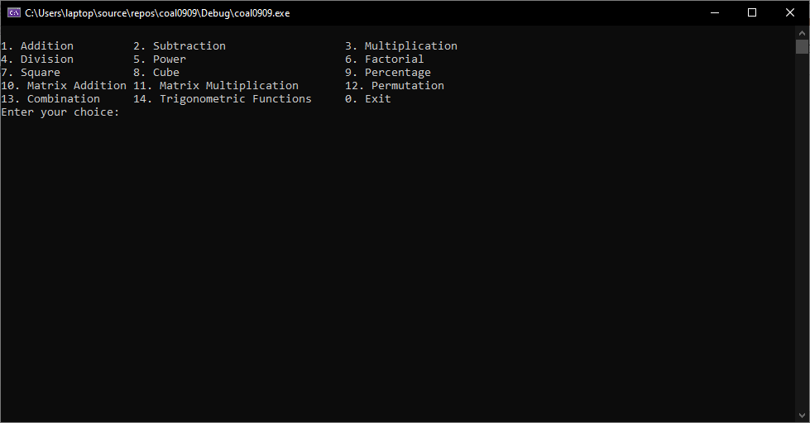

Matrix Multiplication:
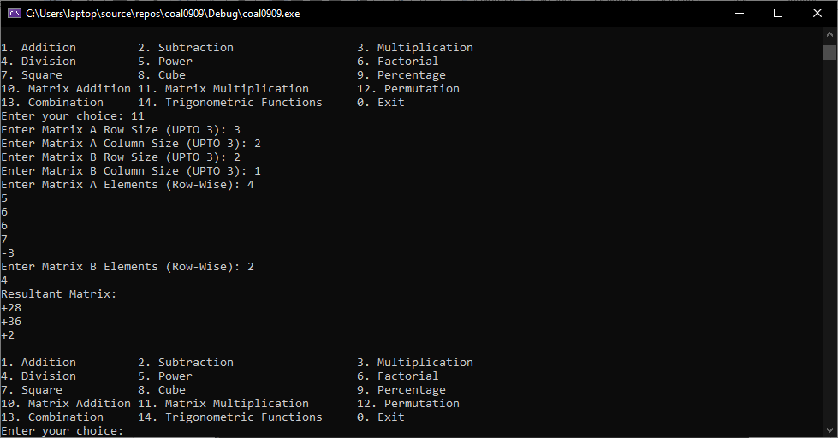
Power (in fraction form):
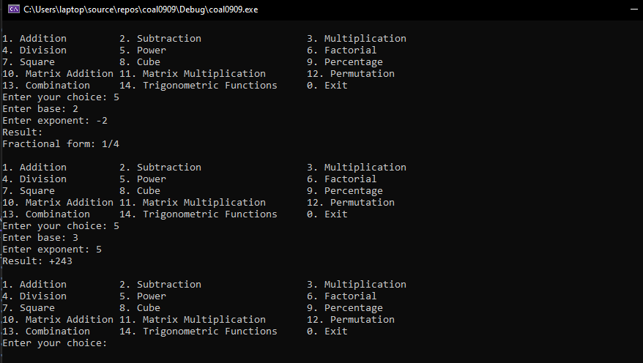
Trigonometric Functions:
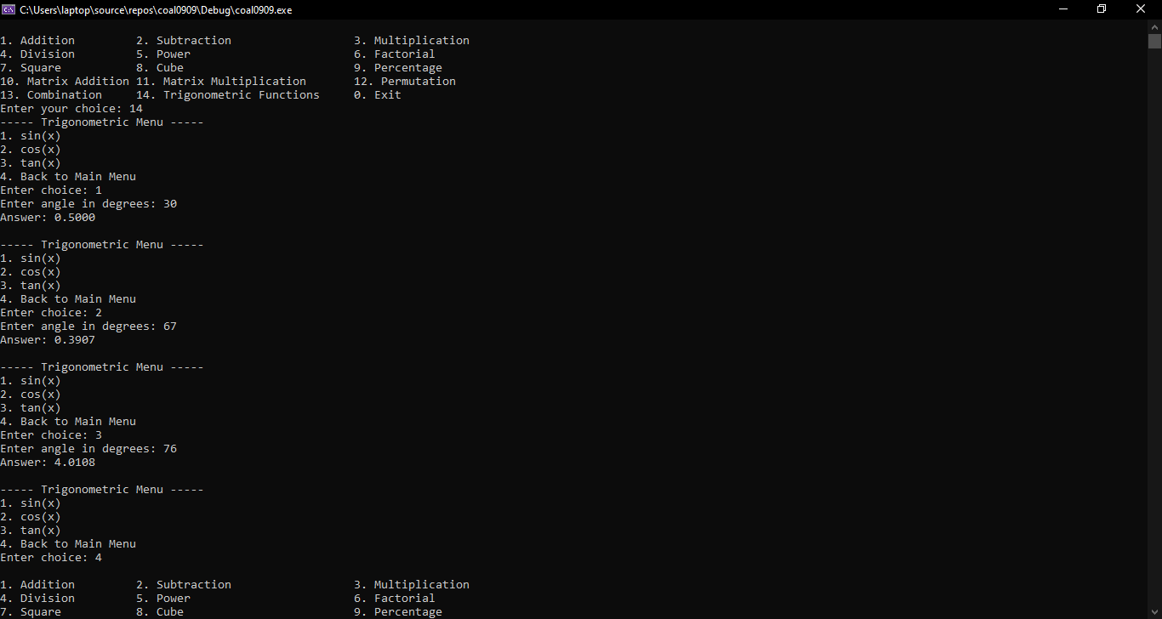

Testing and Validation
- Each module tested individually (unit testing style).
- Tested all menu options for valid and invalid inputs.
- Verified matrix multiplication with known values.
- Compared trigonometry results with Windows calculator (matching up to 4 decimals).

7. Conclusion

Summary of Findings
This project demonstrated that even in low-level languages like Assembly, complex scientific calculations can be implemented through careful use of:
- Modular procedure design
- Mathematical algorithms
- FPU instructions
- Error handling and structured menu interactions
The program successfully performs all intended operations and emulates the modularity principles of OOP.

Final Remarks
The project significantly improved understanding of:
- Assembly Language programming
- Stack operations, registers, memory, loops
- FPU usage
- Large project structuring in low-level programming
Further improvements could include:
- Full floating-point calculator
- Graphical interface
- File-based logging of results

